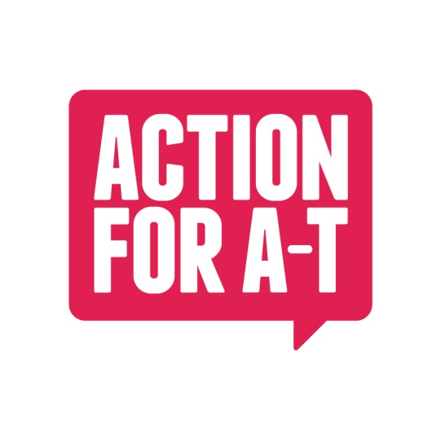
For Office Use Only:

Account Code:…TCSLM2026

Accepted: Paid:

Logged:

LONDON MARATHON 2026 Registration Form

To help us offer you the best available support for your event or fundraising activity, please complete and send in this form.

CHALLENGE DETAILS

Type of Challenge: Running

Name of Challenge: London Marathon 2026

Date of Challenge: 26/04/2026 Type of challenge: Marathon

PERSONAL DETAILS (Please use capital letters)

Title: Name:

Address:

Postcode: Email:

Daytime Telephone No: Mobile:

Date of Birth: Sex:

Occupation: Company:

T-Shirt Size:

RUNNING FOR ACTION FOR A-T

I already have a place in the London Marathon 2026

I have applied for a place through the London Marathon public Ballot

I am applying for an Action for A-T charity place

FUNDRAISING

We would be grateful if you could complete the questions below.

1. How did you hear about Action for A-T?

2. Do you have a personal reason for choosing Action for A-T?

3. How much do you pledge to raise for Action for A-T? (N/B Minimum Fundraising target for an Action for A-T charity place is £2,500)

4. Please describe ways in which you hope to raise this?

5. Does your company provide matched giving? (E.g. they match the donation you make)

Yes / No

6. Have you taken part in a fundraising event before? If yes, please give details:

7. Would you be willing to contact your local media to publicise your fundraising efforts and Action for A-T?

8. What time are you hoping to run the marathon in?

Please feel free to attach further comments on separate paper.

DECLARATION OF INTENT FOR ACTION FOR A-T CHARITY PLACE APPLICANTS

I, confirm that if I am awarded a 2026 ACTION FOR A-T charity Place, I would raise a minimum of £2,500 and agree to abide by the following terms and conditions:

I agree to run solely and exclusively for Action for A-T, registered charity number 1145303.

I accept that the Action for A-T Charity Place would be for my sole use and understand that I would be taking one of the limited Action for A-T Places in the London Marathon 2026.

I pledge to raise a minimum of £2,500 in sponsorship and I understand that there is an initial £500 deadline by 1st March 2026 and that all remaining sponsorship should be returned to Action for A-T no later than 1st June 2026.

I understand that I have a responsibility for ensuring my own fitness to participate in the marathon and will declare all medical details below.

Should I be unable to compete, I will inform Action for A-T as soon as possible.

I have read and understood the above terms of acceptance.

Name (Block Capitals):

Date:

Signature:

MEDICAL DETAILS

Please indicate below if you have any pre-existing medical conditions or are on any medication.

Pre-existing medical conditions:

Details of any hospital treatment in last 12 months:

Medication Taken:

Are you allergic to anything?

NEXT OF KIN DETAILS (If applicable)

Name: Relationship:

Contact Number:

HOW CAN WE HELP?
Please let us know how you would like us to help you with your fundraising:

RECOMMEND A FRIEND
If you would like us to send information about this challenge to a friend please let us know their details below:

Name:…………………………………………………………………….Address:…………………………………………………………………

……………………………………………………………………………………………………..Postcode:…………………………………………

Email:…………………………………………………………………………………Telephone:………………………………………………….

I apply to take part in this challenge and abide by the Conditions of Entry. I confirm to the best of my knowledge my general state of health and fitness is good. I take full responsibility for my fitness to take part.

Signature:

If you require assistance with completing this form please call the Action for A-T office on 01428 853313. Completed forms should be returned to: Sean Kelly, Action for A-T, Aruna House. 2 Kings Road. Haslemere Surrey. GU27 2QA. Or email the form to Sean.Kelly@actionforAT.org

